1. After login you will see the below attached page. Click on Launch a Virtual Machine.

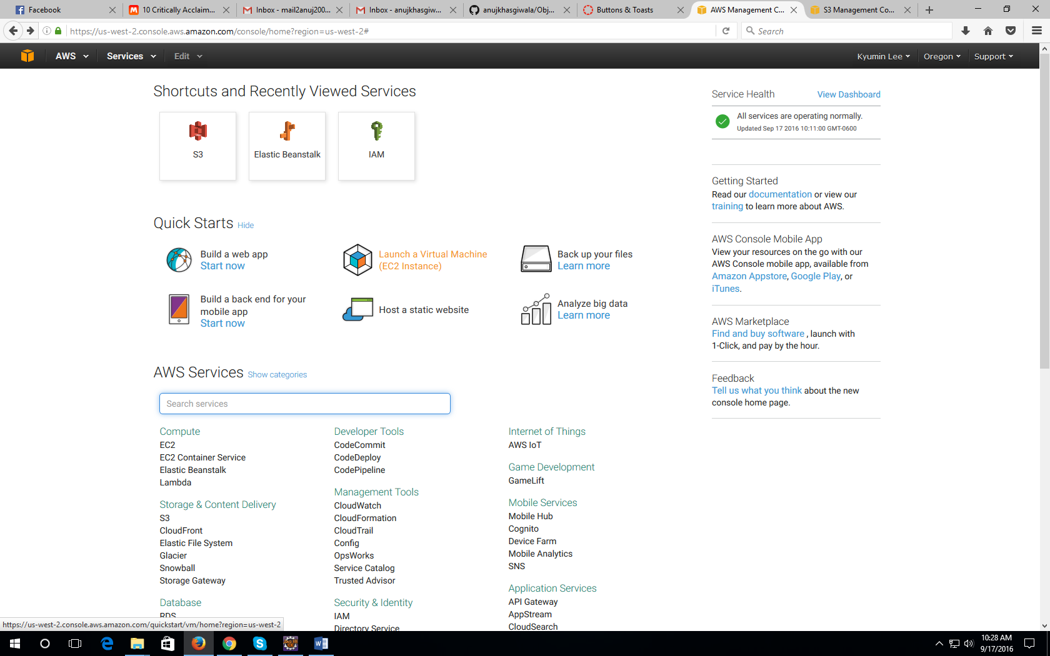

1. Click on “Get Started”

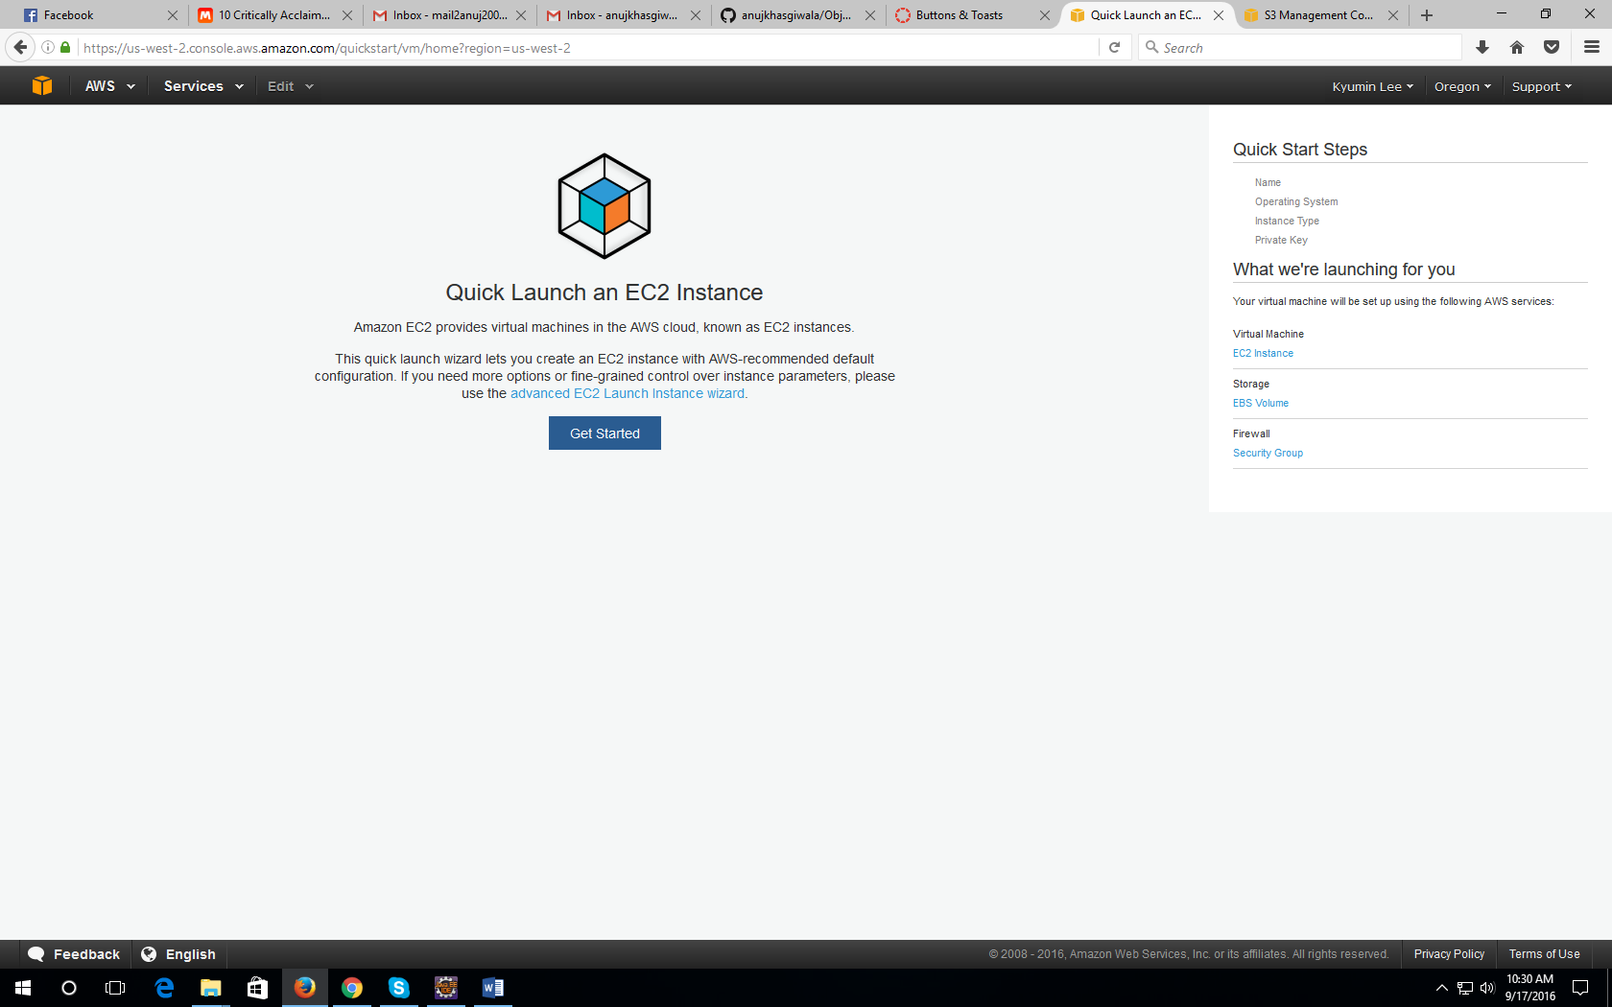

1. Give a name to your new ec2 instance and click use this name

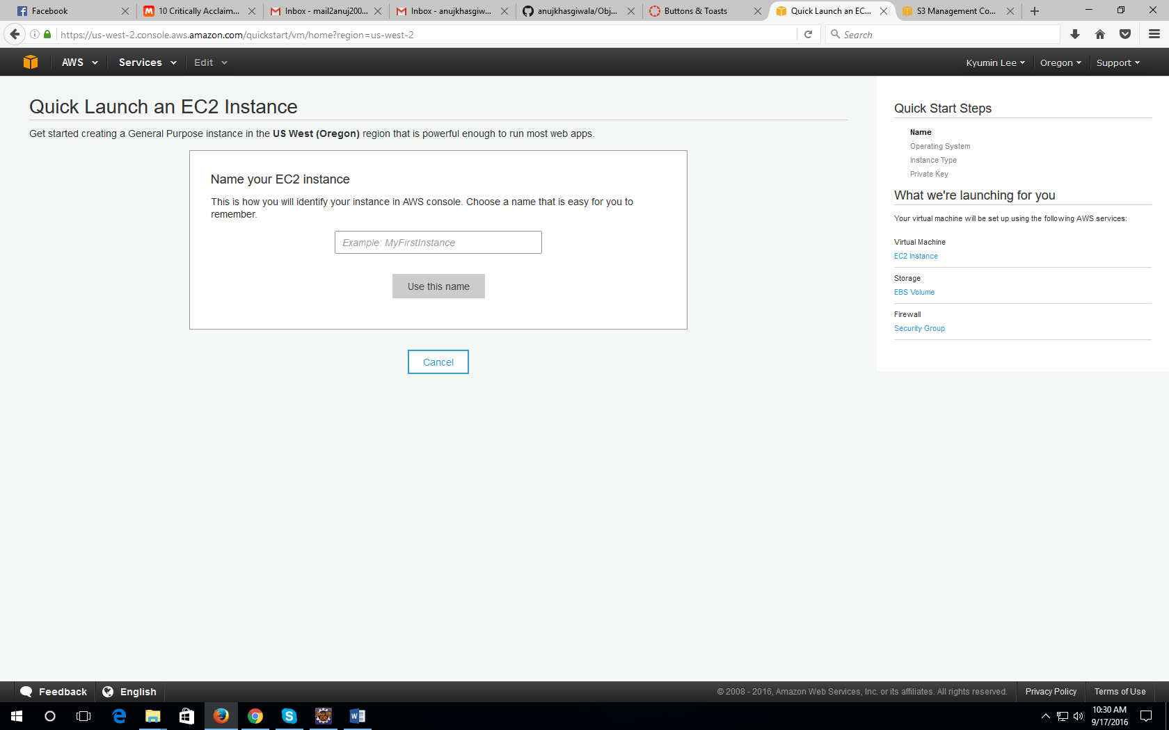

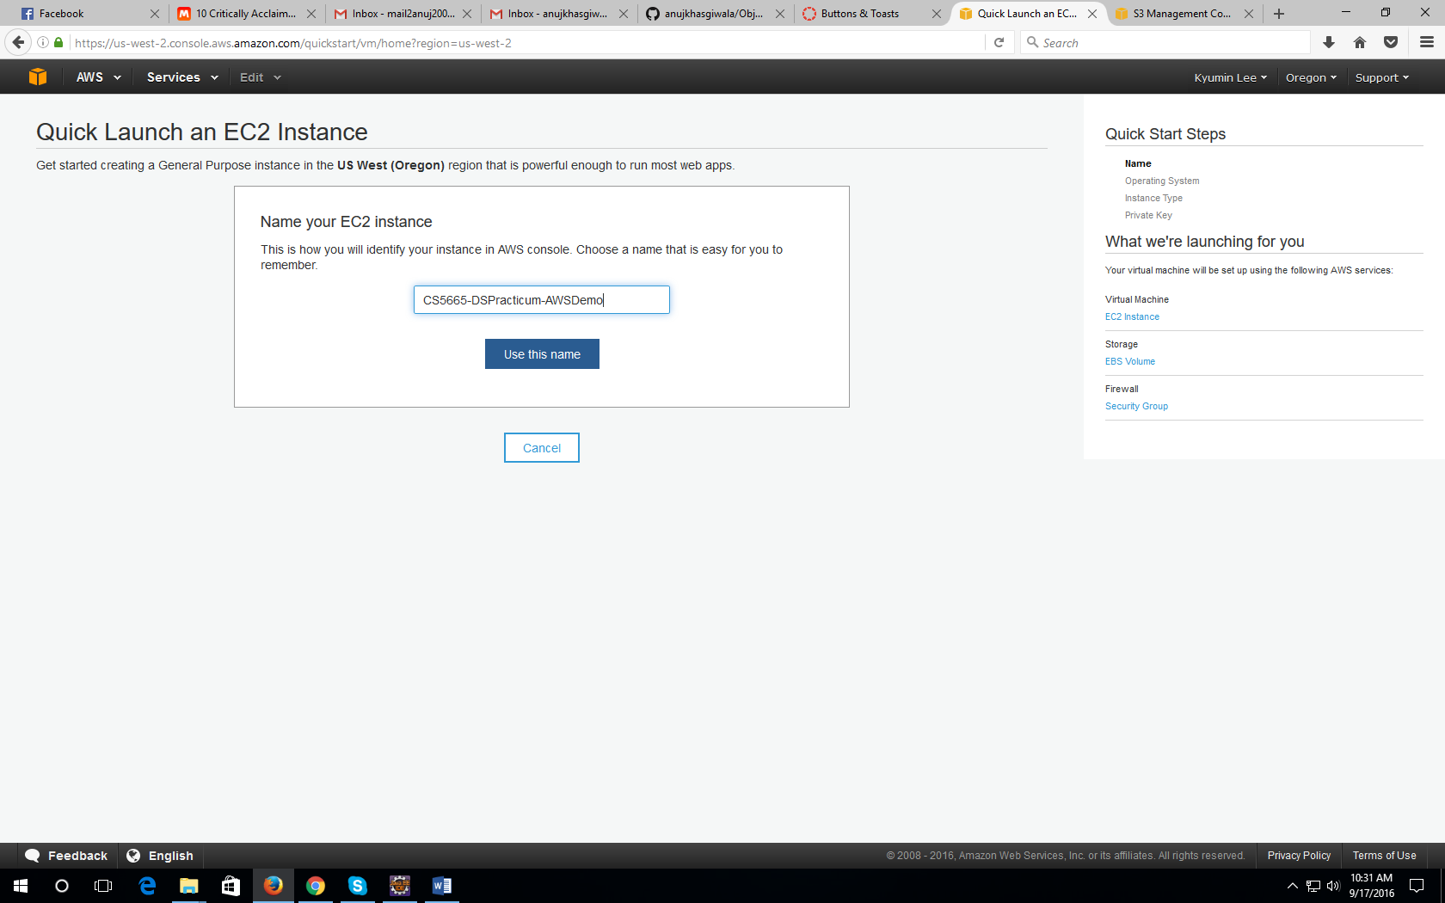

1. On the next screen select the operating system of your choice. I preferred “Amazon Linux”

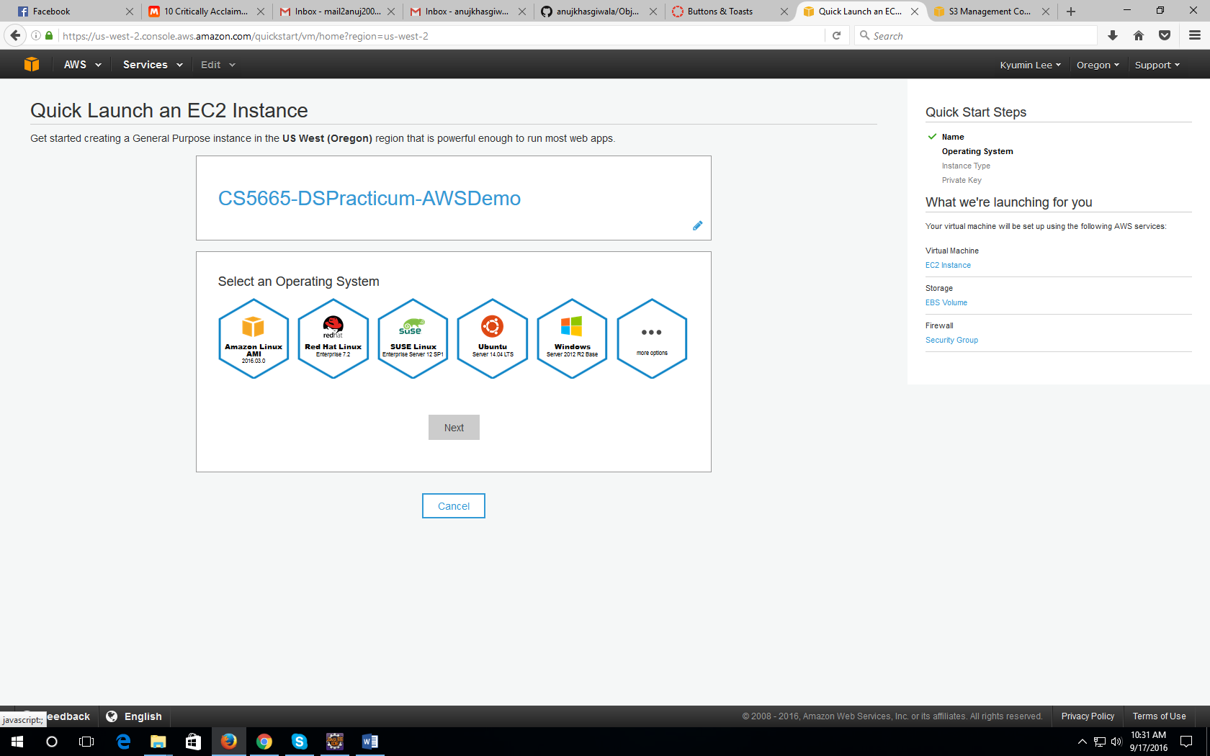

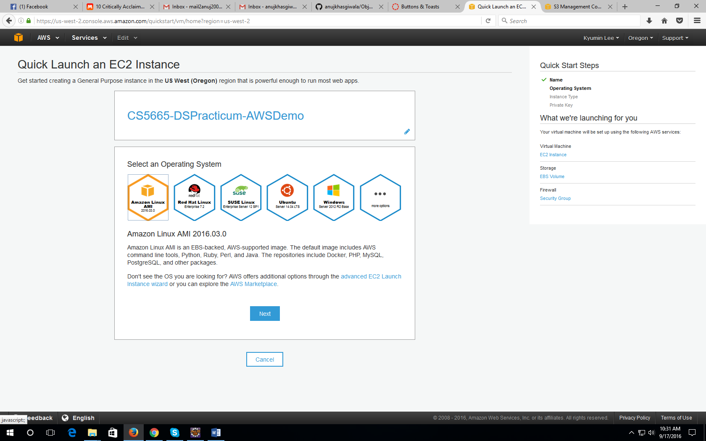

1. Select an instance type of the configurations required and click next. This will generate a key pair which we need to download.

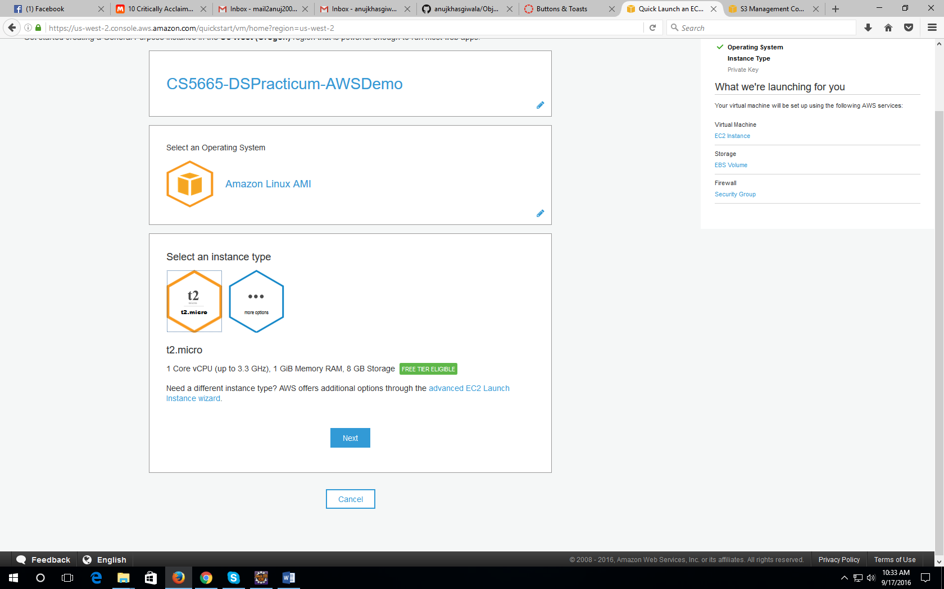

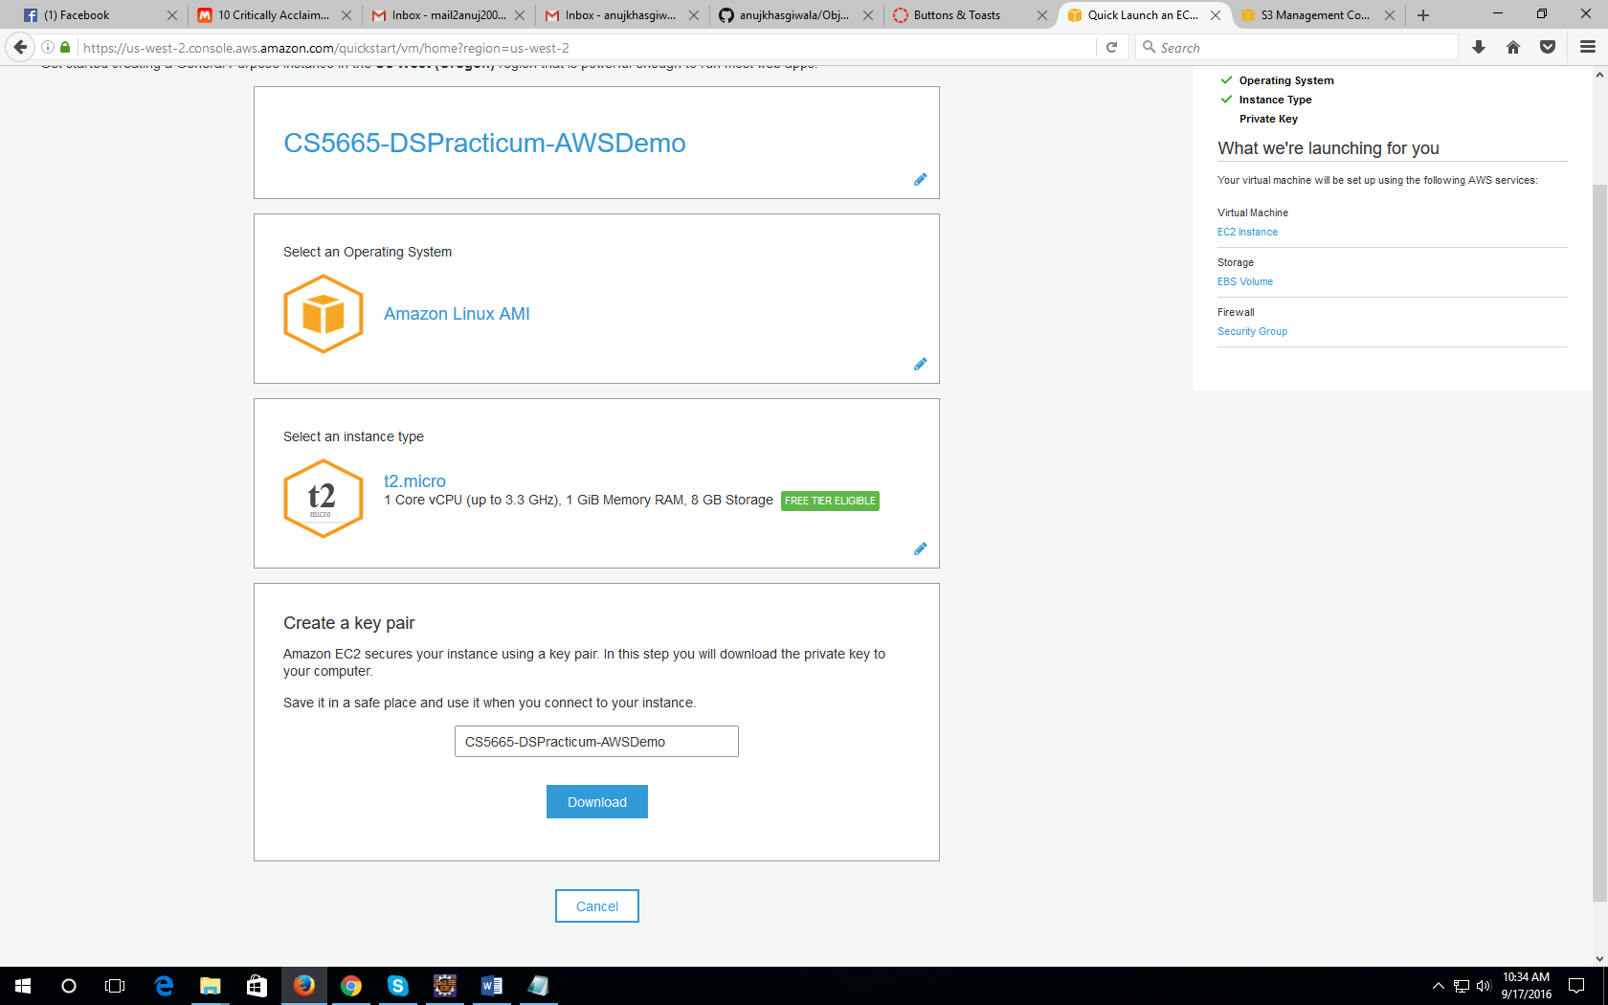

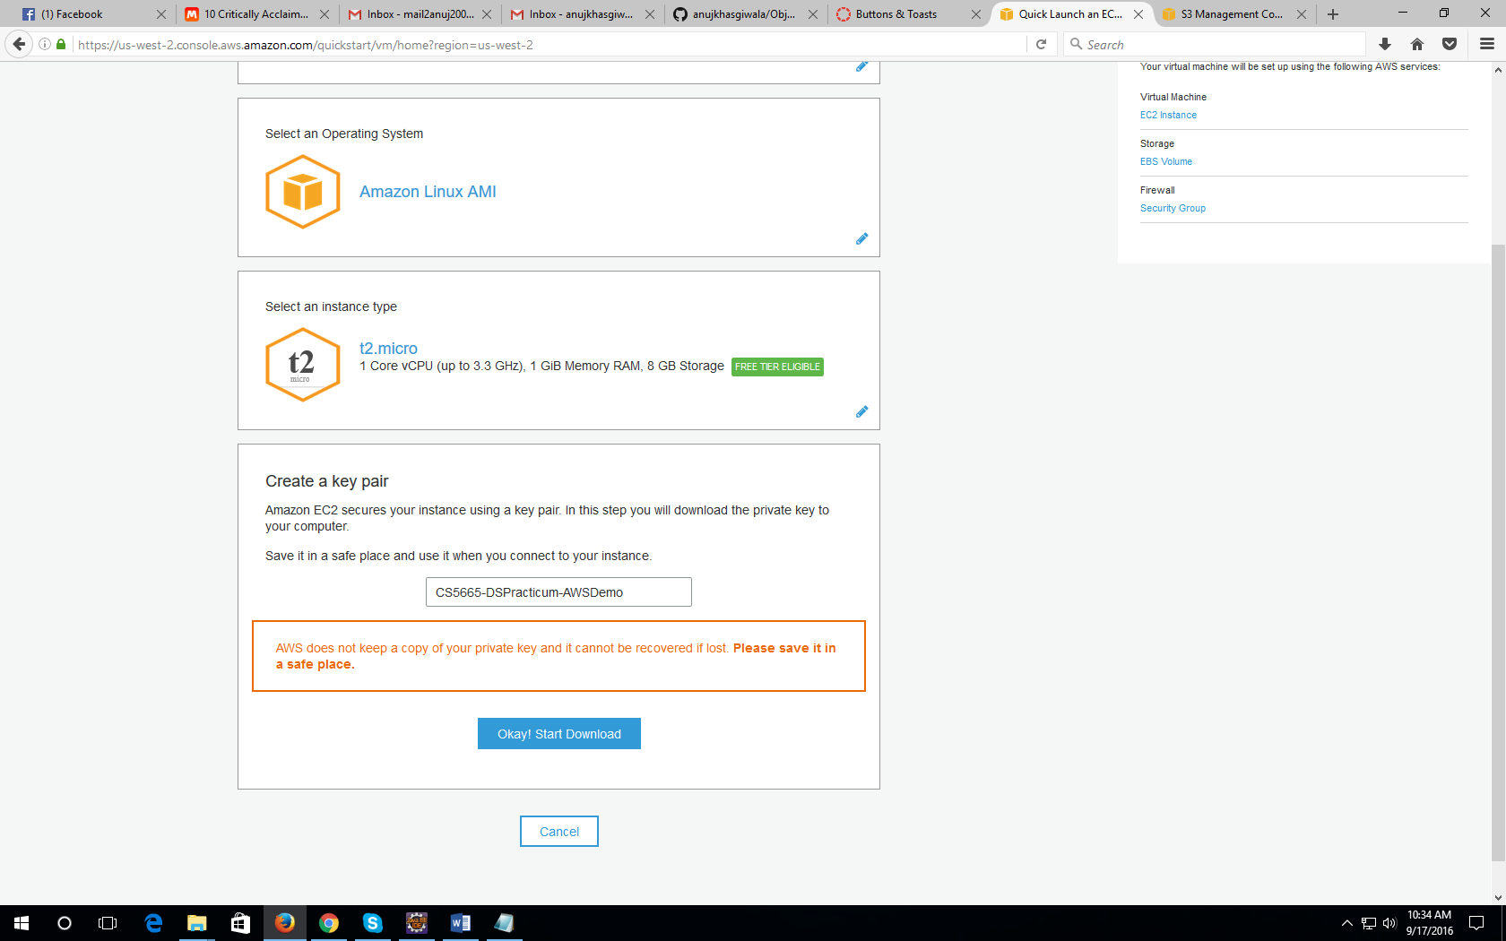

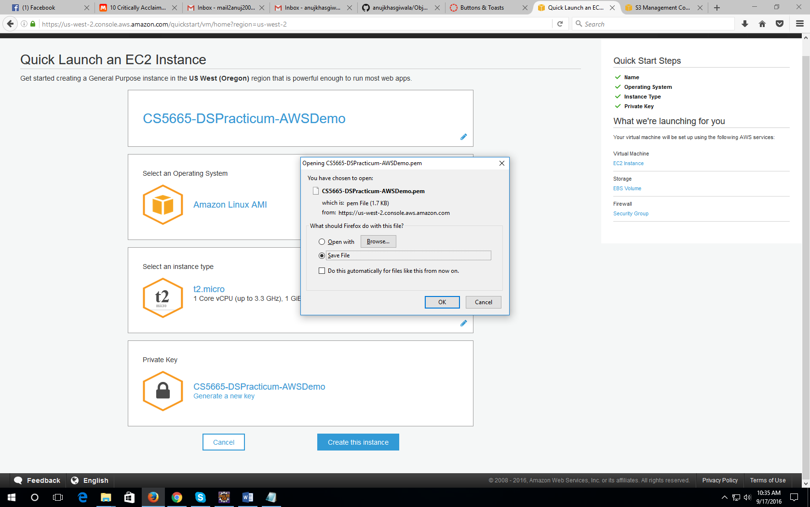

1. Click on “Create an instance”. On the next screen, wait for some time till the status changes to completed.

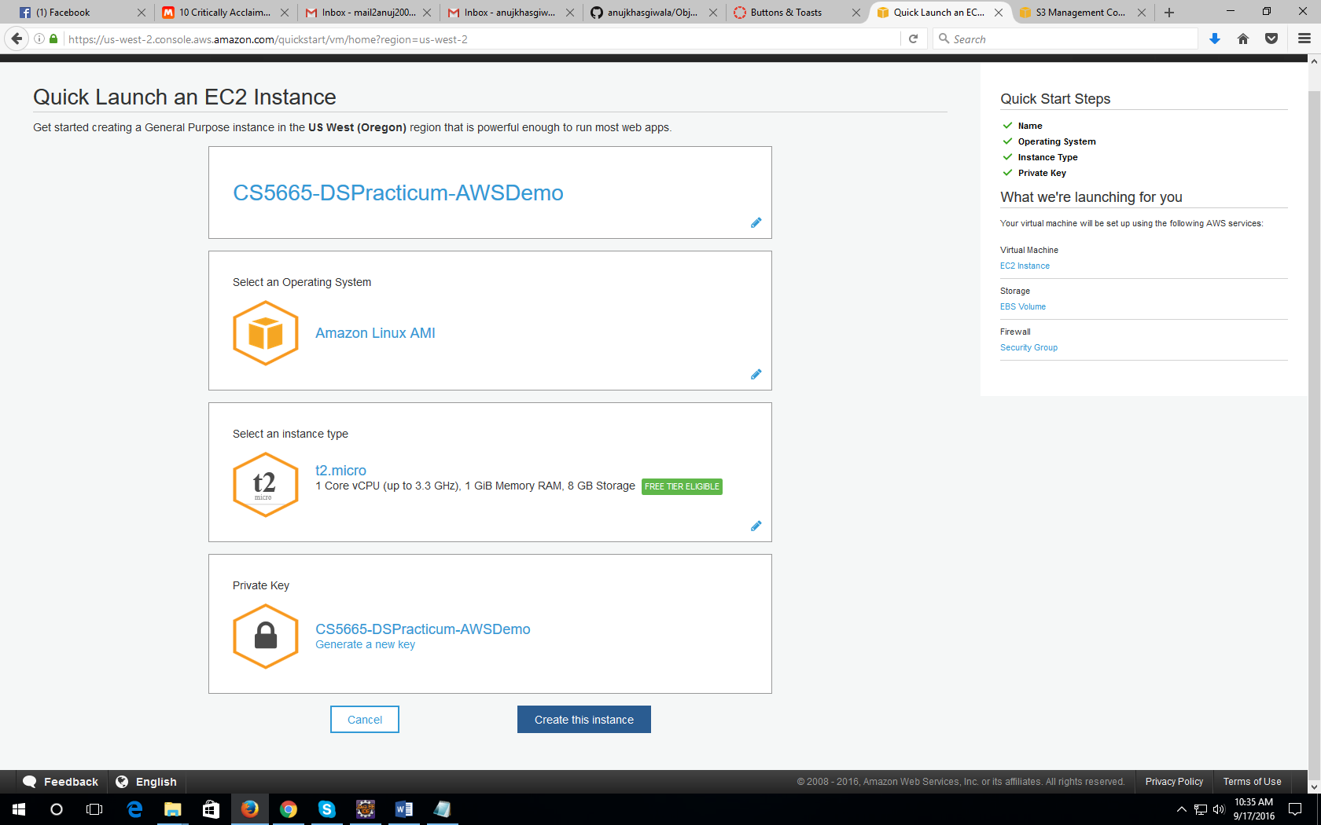

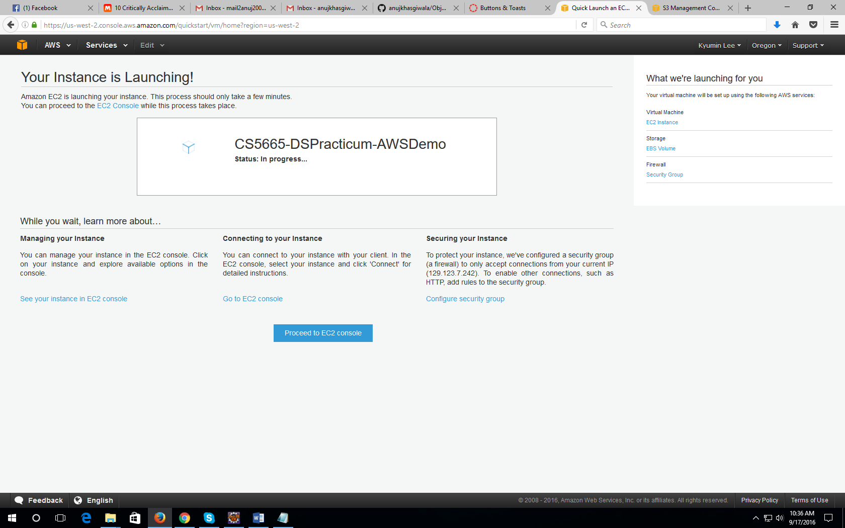

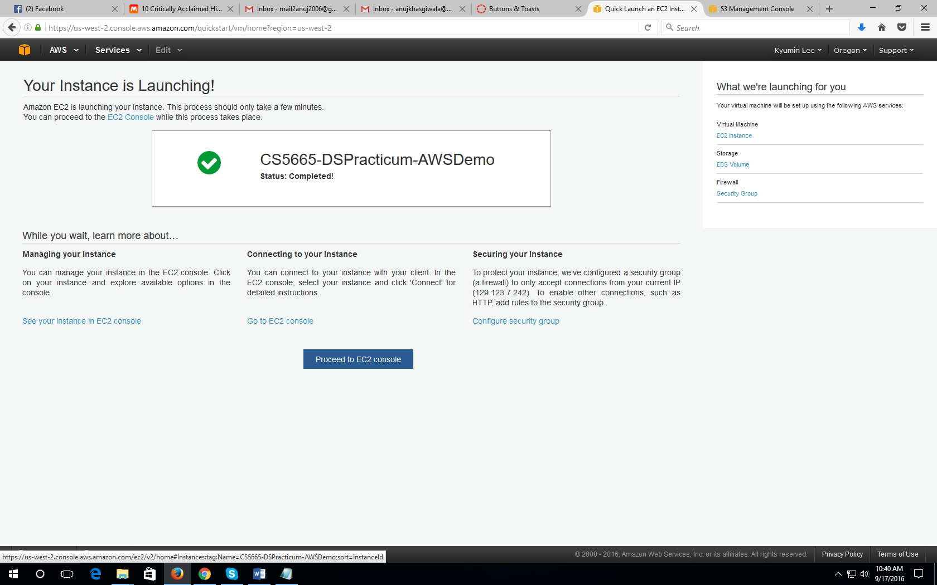

1. On EC2 console click connect. Use putty or java console to connect to your ec2 instance.

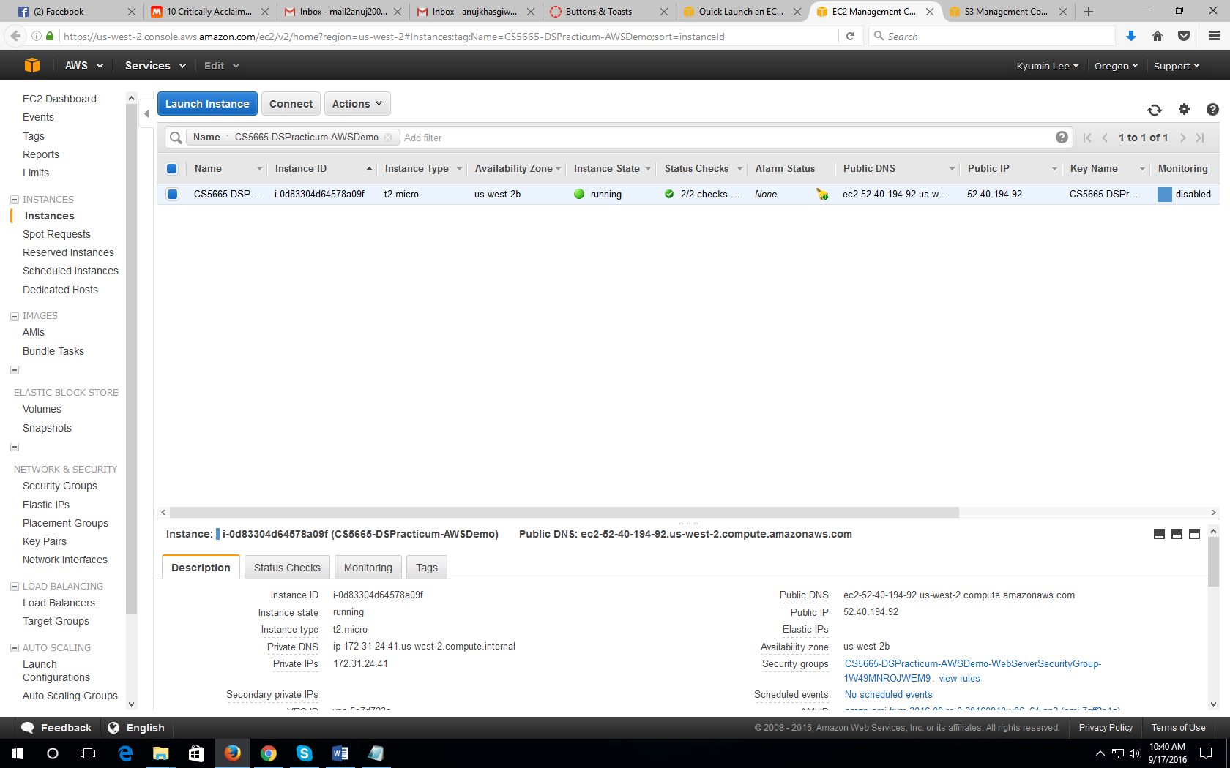

References:

<https://codeforgeek.com/2015/05/setup-node-development-environment-amazon-ec2/>

http://iconof.com/blog/how-to-install-setup-node-js-on-amazon-aws-ec2-complete-guide/